**ASSINGMENT 1 Linux Basics (DevOps)**

1. Creating/Renaming Files/Directories

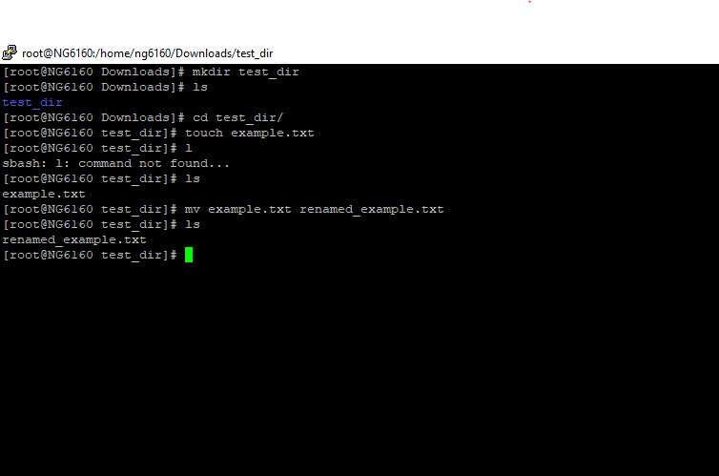

2. Viewing File contents

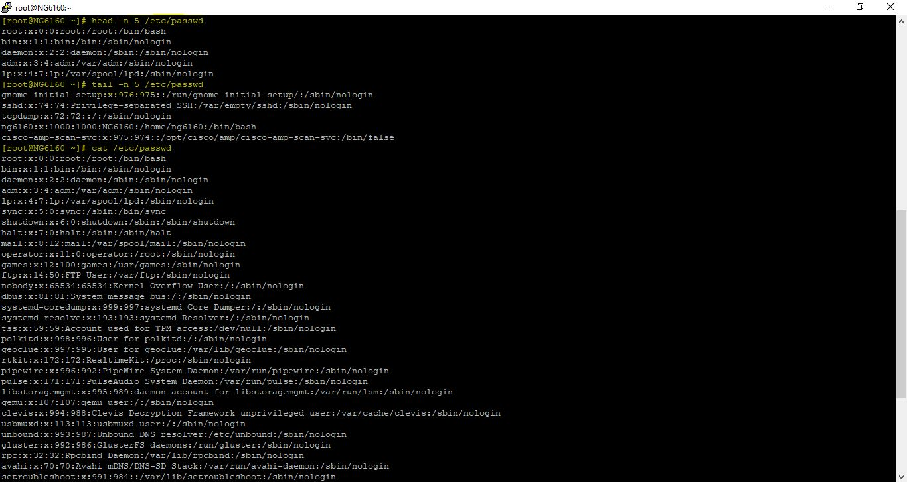

3. Searching for Patterns

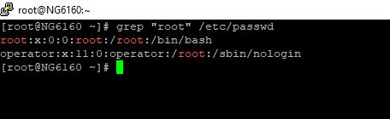

4. Zipping and unzipping

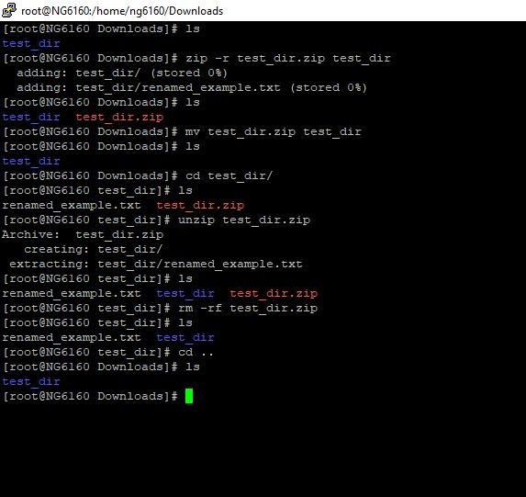

5. Downloading using wget

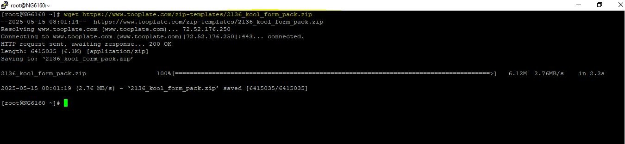

6. Changing Permission

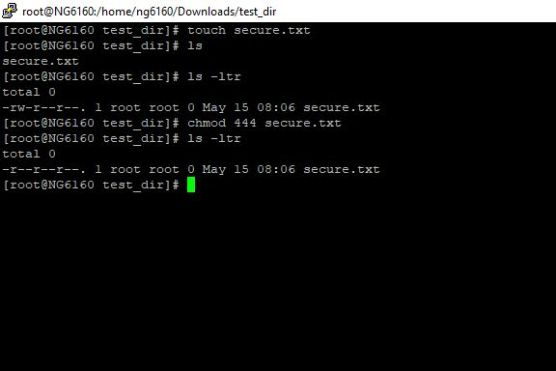

7. Working with Environment Variables

